Preparing Art & Resources for the Development Environment
This documentation outlines the goals and best practices for preparing resources in Adobe Photoshop for integration with tools such as Adobe Animate and Spine. And how to create sprite sheets in Texture Packer.
Contents
Adobe Photoshop art preparation 3
Layers logic and structure 4
Exporting resources from Photoshop to Spine 6
Alternative Export Methods (e.g., for Adobe Animate) 7
Adobe Animate resource preparation 8
Naming Conventions 8
Animation structure 9
Spine resources preparation 10
Importing from Photoshop (via Script before) 10
Importing PNG Files Manually 10
Image Asset Preparation 11
Matching Image Names to Slots 12
Animate Mode & Keyframes 12
Keyframe Rules 12
Rigging Bones 13
Export Settings 14
Data: 14
Image or Video: 14
Sprite sheet creation in TexturePacker GUI 15
Adding new sprites 15
Sprite settings 15
Export settings 17
Output files 18
Image format 18
Packing 19
Publishing a Sprite Sheet 20

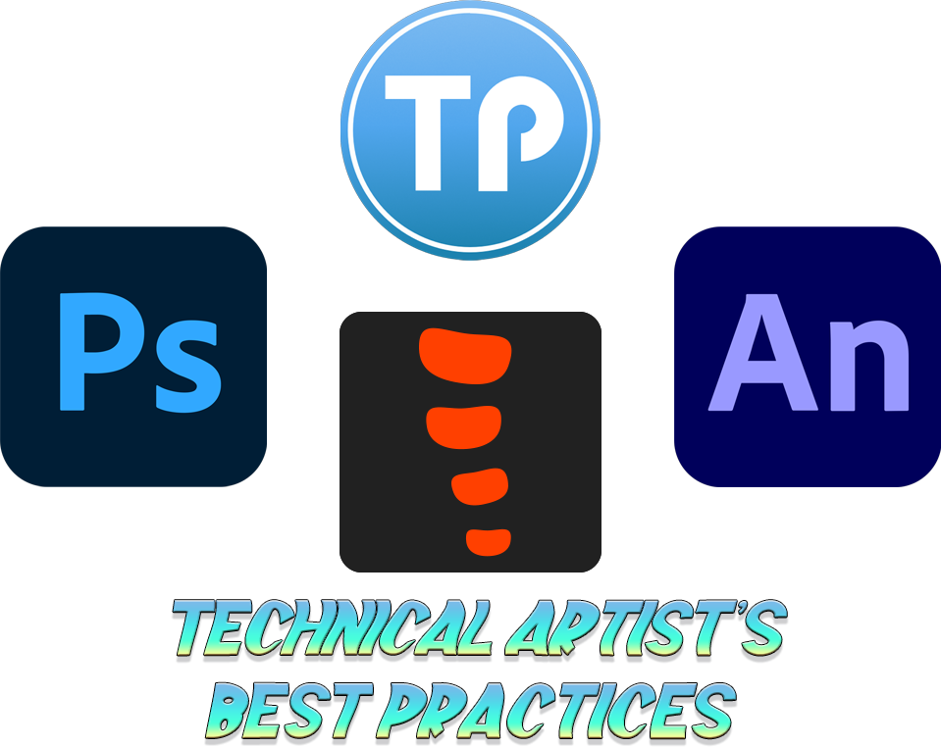

Adobe Photoshop art preparation
Creating a New Project Document
For creating a new document use combination Ctrl + N.
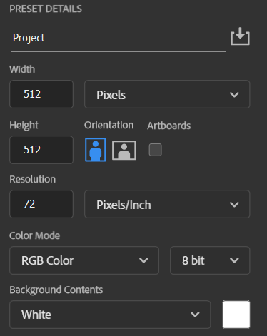
Name the project, set resolution Width x Height depending on your project needs.
Avoid using unnecessarily large canvas sizes, for example, small UI elements like buttons do not require high-resolution documents.
For most Bitmap projects use Resolution 72 PPI.
For Vector image projects use Resolution 300 PPI
Use Color mode → RGB Color
To import resources into a new document, you can either paste them directly into the viewport or drag and drop them from your folder: 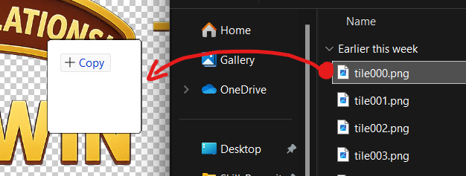

Layers logic and structure
PSD File Requirements:
✅ All layers must be clearly and consistently named, following a logical pattern such as body_head, fx_glow, ui_button_idle, etc.
✅ Use layer groups (folders) to separate logical sections: Body, FX, UI, etc.
✅ Avoid empty layers or layers with default names like Layer 1 or Copy of Layer
✅ Separate elements into different folders. (for example, RightLeg, LeftThigh → Body folder)
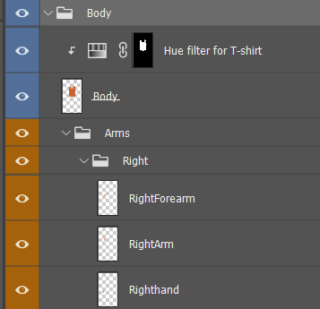
You can see examples of naming and structure on the bottom pictures.
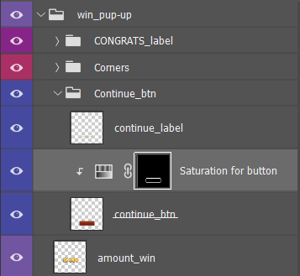

To animate your resources in future, separate your layers and “slice” them logically. It will be easier to work with art. (for example, to animate ALL symbols from this label below separately)
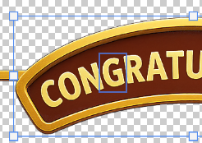
To create more realistic animation of different states of your character (e.g., idle, running etc.), slice body parts into different layers. If any parts are expected to bend or rotate, make sure to extend the artwork space slightly in the bending areas. It helps maintain visual continuity during transformations like rotation or deformation.

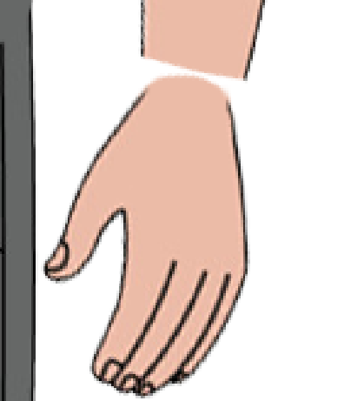
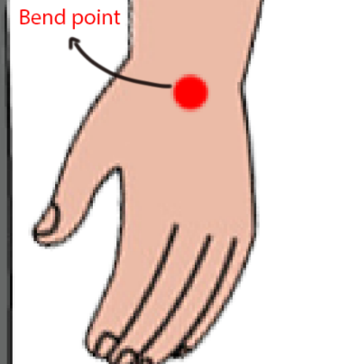
E← Where extra space is needed

Example:
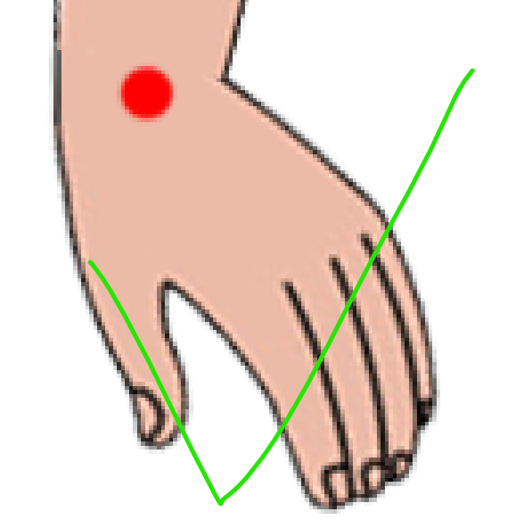
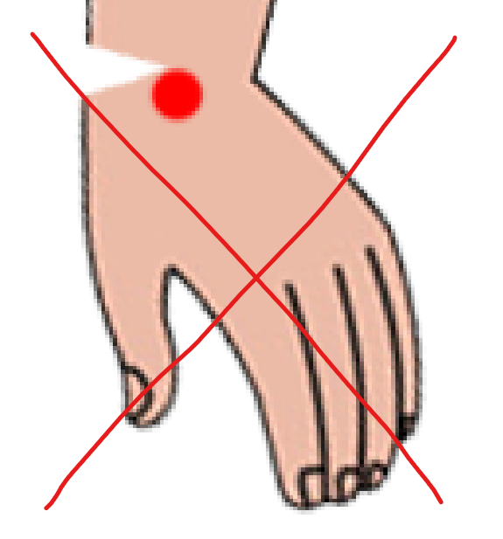
- 2.

Exporting resources from Photoshop to Spine
To export your layers, you can use PhotoshopToSpine Script. It is useful to fast export into .json all your assets from layer. Official EsotericSoftware GitHub
- Go to File → Scripts → PhotoshopToSpine.
- Choose the settings appropriate for your project.
- Ensure the Scale is set to 100% to match your project’s native resolution.
- Set the Output Path, which will be used to save the generated .json file and the exported image assets.
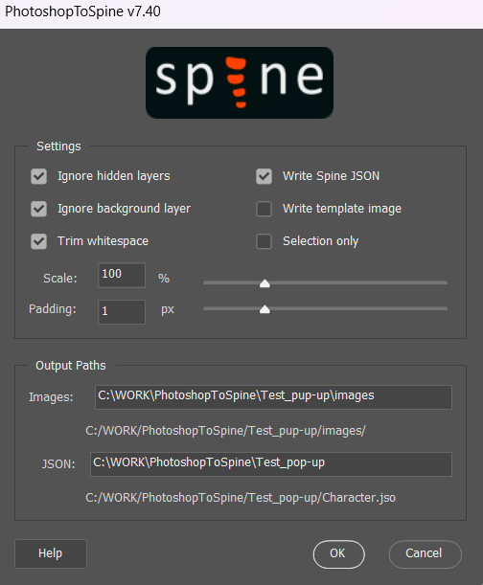

Alternative Export Methods (e.g., for Adobe Animate)
To export in another method (for example to use in future in Adobe Animate) use
File → Export → Layer to Files. (to save canvas size for all layers).
Or
File → Export → Export As … and choose file settings that you need (PNG, JPG formats and so on).
Export Formats:
Target Tool | Format | Notes
Spine | PNG | Transparent background, 72–150 dpi, 100% scale
Animate | PSD / PNG | PSD (for Import), or PNGs with layers

Adobe Animate resource preparation
✅ Import as PSD with layered groups or separated PNG files.
Use: File → Import → Import to Library
✅ Photoshop layer groups = Timeline layers in Animate. (Photoshop layer groups will be automatically converted into timeline layers in Adobe Animate.)
✅ Avoid using complex layer effects or filters that are not supported in Animate (e.g., heavy shadows, glow, bevel, or other Photoshop-specific styles).

Naming Conventions
Use clear and understandable prefixes for other developers to categorize layers:
- label – for labels
- ui_ – for interface elements
- btn – for buttons
- env_ – for background/environment layers
Example of Library naming and structure
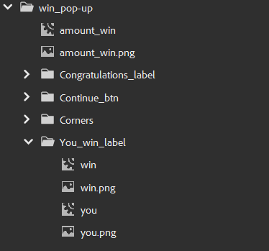
Do not avoid the same logical structure in Timeline viewport:
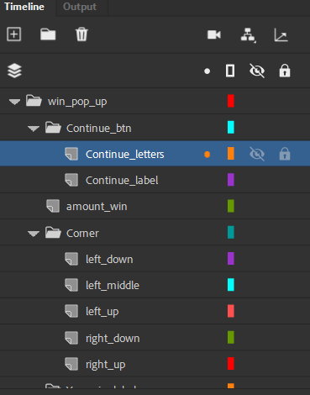

Animation structure
✅ Each animation segment should be in its own Timeline
✅ All animation states in Timeline must end with Keyframe
✅ Idle and similar animations need to be looped (no stretch, edgy and sharp transitions)
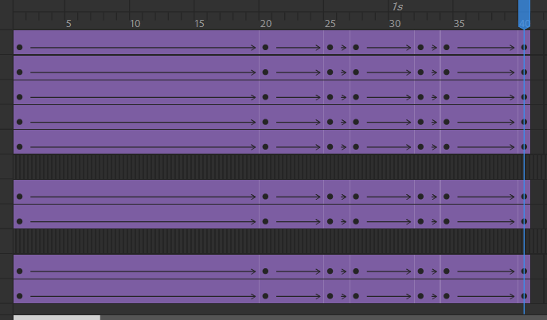

Spine resources preparation

Importing from Photoshop (via Script before)
Go to Spine → Import Data… → JSON or binary file → File path → Import.
Select folder where you’re exported .json file from Photoshop script saved.
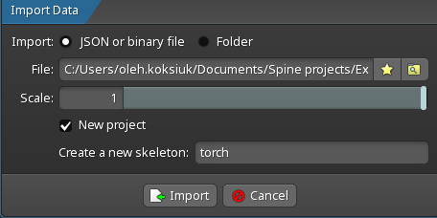

Importing PNG Files Manually
In Spine go to Tree → Images and then on bottom area choose Browse and select folder with your assets that need to be imported.
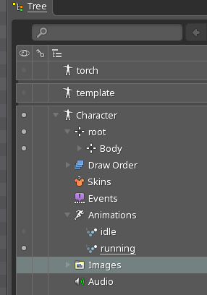
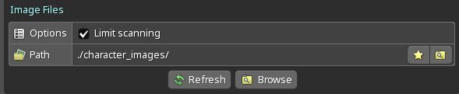

Image Asset Preparation
After importing assets, you need to Parent them to Bones.
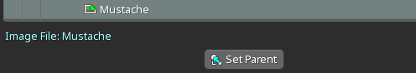
You can just drag the image to Bone, or select image then Set Parent and choose Bone.
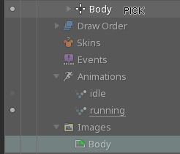
✅ Use PNG format for all assets that need to be animated (or JPG format for static images e.g. backgrounds).
✅ Resolution should match target device scale (1x, 2x). Do not overscale it.
✅ File names must be unique, logically understandable, no spaces.
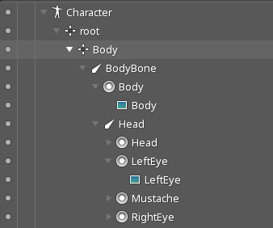

Matching Image Names to Slots
- Slot name must match the PNG filename (without extension)
- Example:
  - Slot: Head
  - Head: Head.png ✅
  - 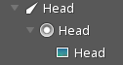

Animate Mode & Keyframes
✅Switch to Animate mode only after skeleton and assets are set.
✅Keep animations in their own timelines: idle, walk, run, jump, attack.
✅Avoid animations states and Keyframes on root bone.

Keyframe Rules
✅Use keyframes for bones and slots.
✅Avoid unnecessary keys. Only key what changes something.
✅Idle and similar animations need to be looped (no stretch, edgy and sharp transitions). And starts and ends with Keyframe:
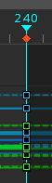
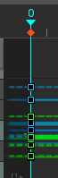

Rigging Bones
✅Use a hierarchical structure (as folders in Tree) Body → LeftArm → LeftForearm → LeftHand
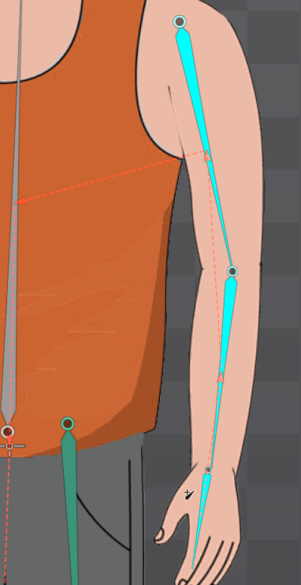
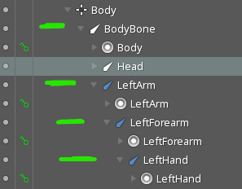

✅Rotate bones from pivot points (e.g. shoulder, elbow)
✅Always preview all animations inside Spine before export by Preview mode Alt + R and check:
- Bone rotations
- Attachments switching correctly
- Timing of keyframes
- Looping for idle/walk cycles

Export Settings
✅Keep image resolution optimized — not larger than needed.
✅Always export using Spine runtime version required by the engine.
Use Spine → Export
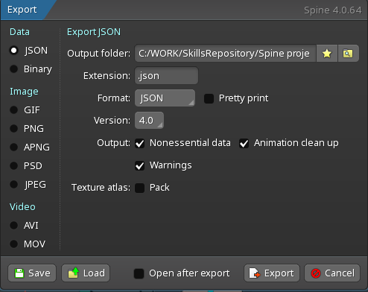

Data:
Check .json if you need to integrate assets in future development environments
And set options Output folder where will be located .json file of project and runtime Version of Spine

Image or Video:
To export project resources (animations, skeleton) in video or image format.

Sprite sheet creation in TexturePacker GUI

Adding new sprites
Add new sprites via Add sprites or Add smart folder if you need to add multiple quantities.
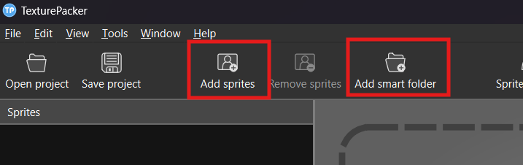

Sprite settings
If you need to create a sprite sheet for frame-by-frame animation, recommended to set correct pivot for each asset.
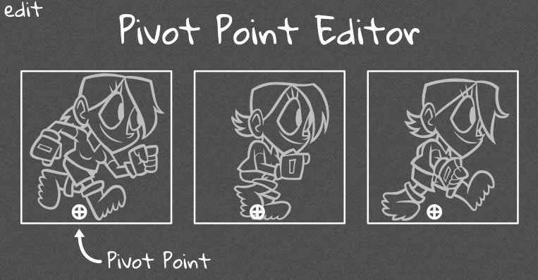
Use Sprite settings → Settings → Pivot point
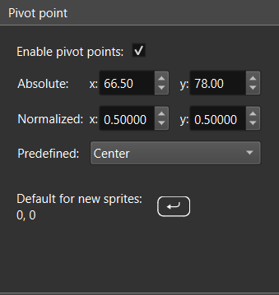
Or you can adjust it manually by selecting each asset in Sprite panel and moving pivot point.
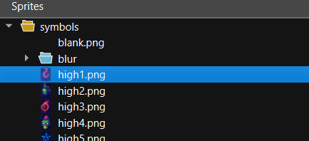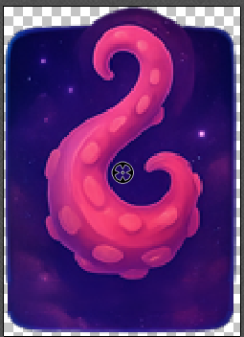

Export settings
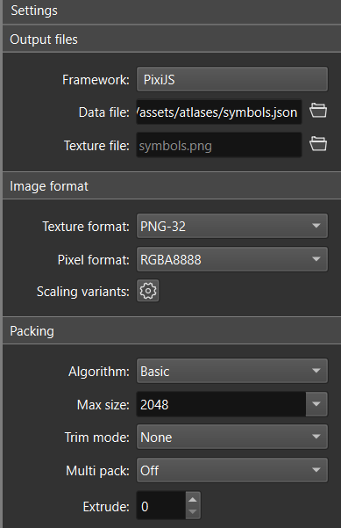

Output files
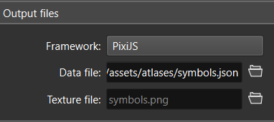
Choose Framework as required in your project (e.g. PixiJS)
Set path where will be saved .json file of sprite sheet

Image format
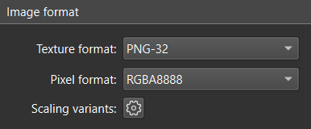
Select texture format (PNG-32 and alpha channel recommended)

Packing
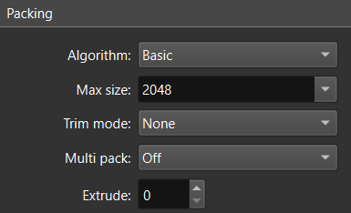
The algorithm sets layouts by filling sprites from left to right until the maximum width of texture is reached.
✅Basic is good for fixed-size sprites
Trim mode removes transparent pixels from a sprite’s border
✅None as by default. It keeps the sprites as they are without removing transparent pixels

Publishing a Sprite Sheet
✅ After all the settings are done, click Publish sprite sheet and in folder that selected, will be .json file and PNG of textures
